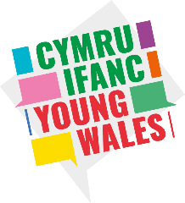
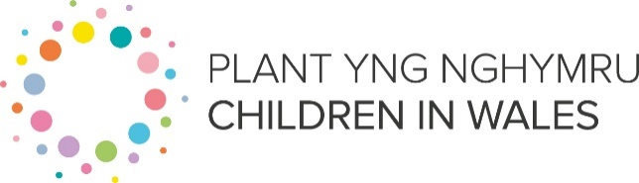
Volunteer Role: National Youth Stakeholders Group

Children in Wales is the national umbrella body for organisations and individuals who work with children, young people and their families in Wales. Young Wales is a Children in Wales initiative funded by Welsh Government. We are about listening to young people and empowering their voices. Our work is built on the ideas of sharing, informing and changing policy and practice.
Purpose of the role | The National Youth Stakeholders Group is for young people with lived experience or a special interest in relation to mental health and wellbeing. The group aims to address mental health issues shared by young people and review mental health and wellbeing initiatives by the Welsh Government and other organisations across Wales. The types of work that you could get involved in includes reviewing, developing and testing how Welsh Government are working to improve mental health and wellbeing services in schools, local authorities and health (like CAMHS).
Meetings | 6 x 2 hour hybrid meetings per year
Age range | 14 to 25
Criteria: | Lived experience of (or a special interest in) mental health and wellbeing
Benefits of Volunteering | - You will develop a range of skills and experience that will look great on your CV!  - Be able to access free training from Children in Wales.  - Have the opportunity to meet other young people from across Wales.  - Accessing UNCRC Article 12; the right to have opinions and for these opinions to be heard and taken seriously.
How to apply | To get involved and start your Young Wales volunteering journey, complete our registration form https://forms.office.com/e/L0a1etADvf  If you would like further information please contact: volunteer@childreninwales.org.uk

Children in Wales is an inclusive organisation and we therefore positively welcome children and young people from a variety of backgrounds, cultures and communities to become young volunteers. All young people will be treated fairly throughout your experience with us and support will be provided wherever possible to ensure you are able to positively and actively contribute.

Rôl Wirfoddol: Grŵp Rhanddeiliaid Ieuenctid Cenedlaethol

Plant yng Nghymru yw’r corff trosfwaol cenedlaethol ar gyfer sefydliadau ac unigolion sy’n gweithio gyda phlant, pobl ifanc a’u teuluoedd yng Nghymru. Menter Plant yng Nghymru yw Cymru Ifanc, sy’n cael ei hariannu gan Lywodraeth Cymru. Ein bwriad yw gwrando ar bobl ifanc a grymuso eu lleisiau. Mae ein gwaith wedi’i seilio ar syniadau ynghylch rhannu, llywio a newid polisi ac ymarfer.

Diben y rôl | Mae’r Grŵp Rhanddeiliaid Ieuenctid Cenedlaethol ar gyfer pobl ifanc sydd yn aml â phrofiad bywyd neu ddiddordeb mewn perthynas ag iechyd meddwl a lles. Nod y grŵp yw mynd i’r afael â materion iechyd meddwl a rennir gan bobl ifanc ac adolygu mentrau iechyd meddwl a lles gan Lywodraeth Cymru a sefydliadau eraill ledled Cymru. Mae'r math o waith y gallech fod yn rhan ohono yn cynnwys adolygu, datblygu a phrofi sut mae Llywodraeth Cymru yn gweithio tuag at wella gwasanaethau iechyd meddwl a lles mewn ysgolion, awdurdodau lleol ac iechyd (fel CAMHS)
Cyfarfodydd: | 6 x cyfarfod hybrid 2 awr y flwyddyn
Ystod oedran | 14 i 25 oed
Meini Prawf: | Profiad bywyd o (neu diddordeb mewn) iechyd meddwl a lles
Manteision Gwirfoddoli | - Datblygu ystod o sgiliau a phrofiad a fydd yn edrych yn wych ar eich CV!  - Gallu derbyn hyfforddiant am ddim gan Plant yng Nghymru.  - Cael cyfle i gwrdd â phobl ifanc eraill o wahanol rannau o Gymru.  - Mae’n bosib y cewch hefyd dreuliau gwirfoddoli rhesymol, a gytunwyd ymlaen llaw.  - Cael mynediad at Erthygl 12 CCUHP; yr hawl i fod â barn, a bod y farn honno’n cael ei chlywed a’i chymryd o ddifri.
Sut mae gwneud cais | I fod yn rhan o hyn a chychwyn eich taith wirfoddoli gyda Cymru Ifanc, llanwch ein ffurflen gofrestru trwy glicio yma. https://forms.office.com/e/L0a1etADvf  Os hoffech chi gael rhagor o wybodaeth, cysylltwch â: volunteer@childreninwales.org.uk
Mae Plant yng Nghymru yn sefydliad cynhwysol, ac o ganlyniad rydyn ni’n rhoi croeso cynnes i blant a phobl ifanc o amrywiaeth o gefndiroedd, diwylliannau a chymunedau ddod yn wirfoddolwyr ifanc. Bydd pob person ifanc yn cael eu trin yn deg ar hyd eich profiad gyda ni, a byddwn ni’n eich cefnogi ym mhob modd posibl i sicrhau eich bod chi’n gallu gwneud cyfraniad cadarnhaol, gweithredol.

