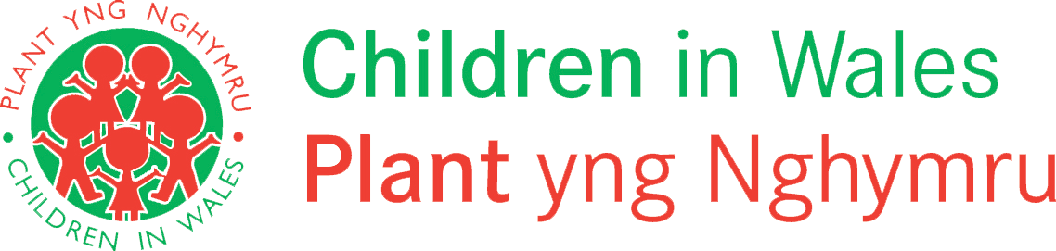

Getting More Involved in Social Care Project (2016-20)
Care Experienced Children & Young People element: End of Project Report
The Getting More Involved in Social Care project has been working with care experienced young people and the professionals who support them from across Wales for the past 4 years. However, the project is now coming to a close.
Following a period of development to get the project set up and running, and to get staff in place, the project has developed some fantastic resources which are all available on our website to download and to use. Although we won’t now be developing any new resources or updating existing ones, these will remain on our website for children, young people and professionals to access. The guides designed with young people, and for young people can continue to be downloaded easily on a phone or tablet or printed if preferred. Our guides can also continue to be used as training tools and by professionals who are working with children and young people who are care experienced.
Whilst the legacy of the project may be recognised through the health and social care thematic and practical resources we have produced, a great deal more has been achieved over the duration of the project, not least, helping to ensure that care experienced children and young people have a voice and control in matters concerning them, in line with Article 12 of the UNCRC.
Some of our achievements include –
- 12 Guides developed and published with and for care experienced children and young people on priority issues they identifies and they wished to have more information about.
- A series of publications and informative resources for a range of professionals who provide care and support for care experienced children and young people
- Training and workshops delivered to care experienced children and young people from across Wales based on the Guides
- Bespoke workshops and conference sessions delivered with care experienced young people to a range of multi-agency professionals in national and local events in Wales
- Train the trainer sessions with care experienced young people
- Representation on policy, practice and strategic groups facilitated by our partners and Welsh Government, promoting the issues that matter to care experienced children and young people.
- Contributions to advisory groups developing publications and guides on issues pertaining to the lives of care experienced children and young people
- Support for Voices from Care Cymru in respect of their policy, campaigns and advocacy work
Throughout the project we have enabled children to have a stronger voice and control in matters that affect them, in line with the Social Services & Well-being (Wales) and Article 12 of the UNCRC. Care experienced children and young people also have a right to accurate information, and we were able to meet Article 13 of the UNCRC through their active involvement and contributions. Our aim was for more care experienced young people to be aware of their health rights and to have more of a say when decisions are being made.
A super big THANK YOU! To all the young people who have contributed to our work.
We would also wish to acknowledge the financial support from the Welsh Government which enabled the project to get started and flourish, and to our partners Voices from Care Cymru for some of the activities delivered under the grant. We would also wish to give recognition to the public bodies in local government and health for their support and involvement, as well as a whole host of third, community and private sector organisations who have played an important part in enabling us to engage with care experienced children from across Wales and the professionals who play a vital role in support them.
The resources can be accessed here www.childreninwales.org.uk/resources/looked-after-children

