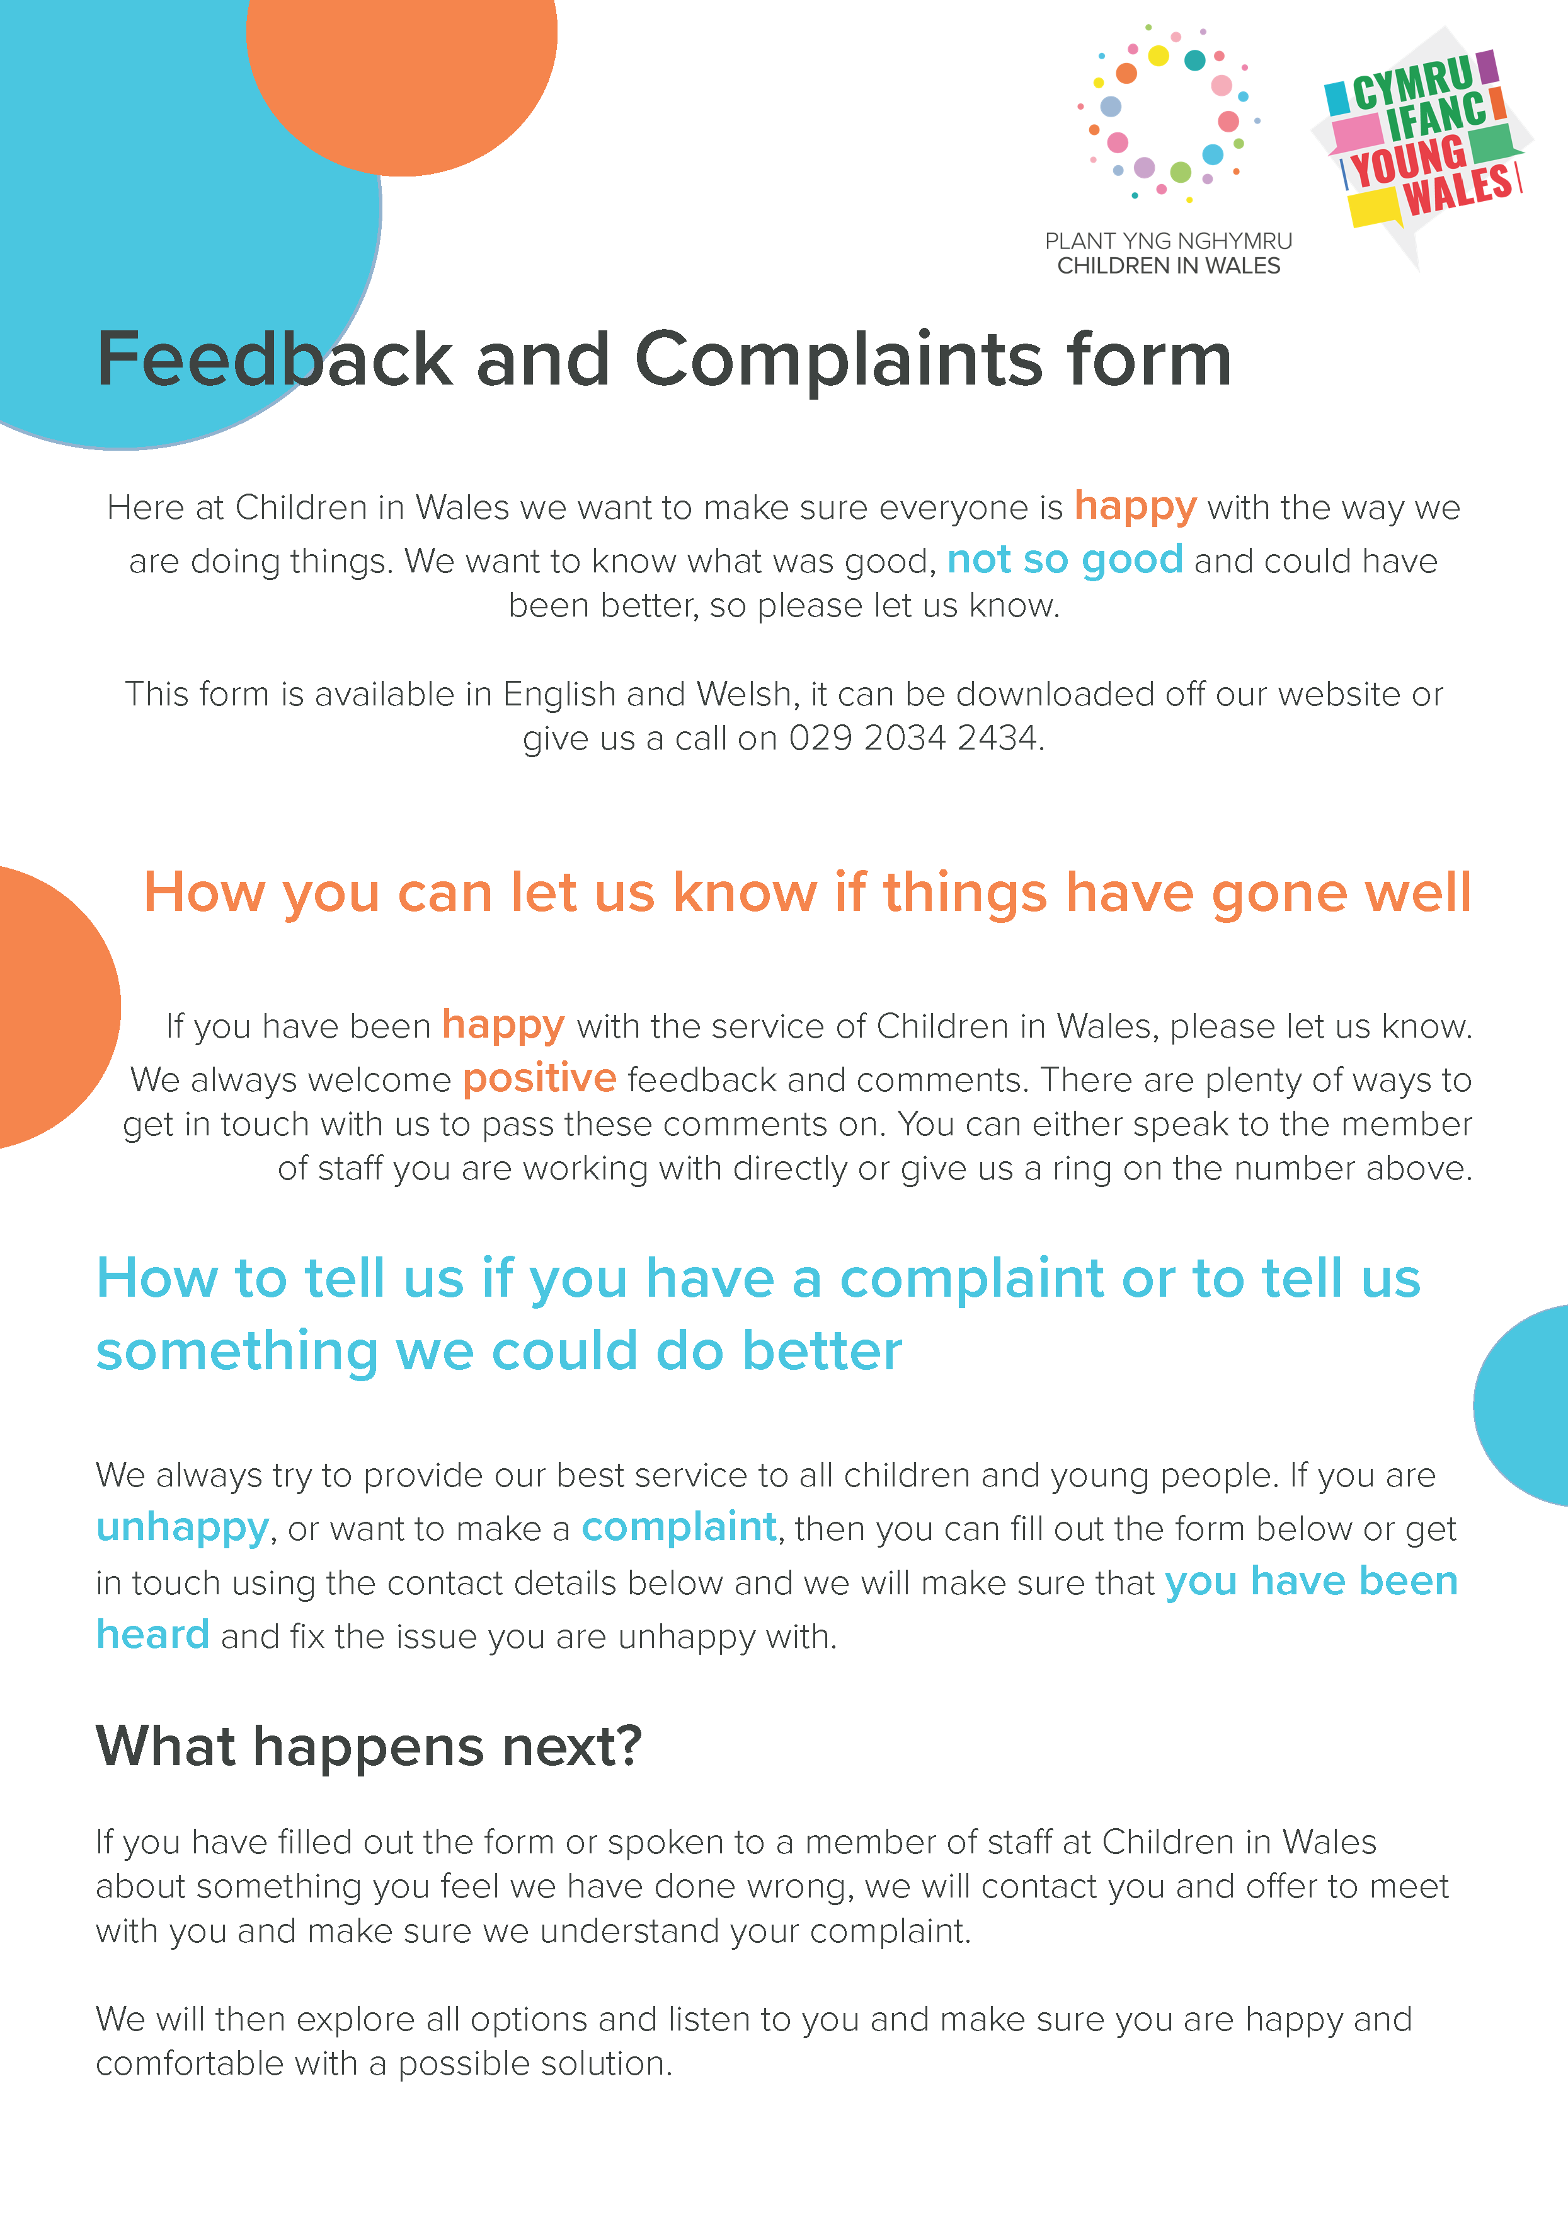

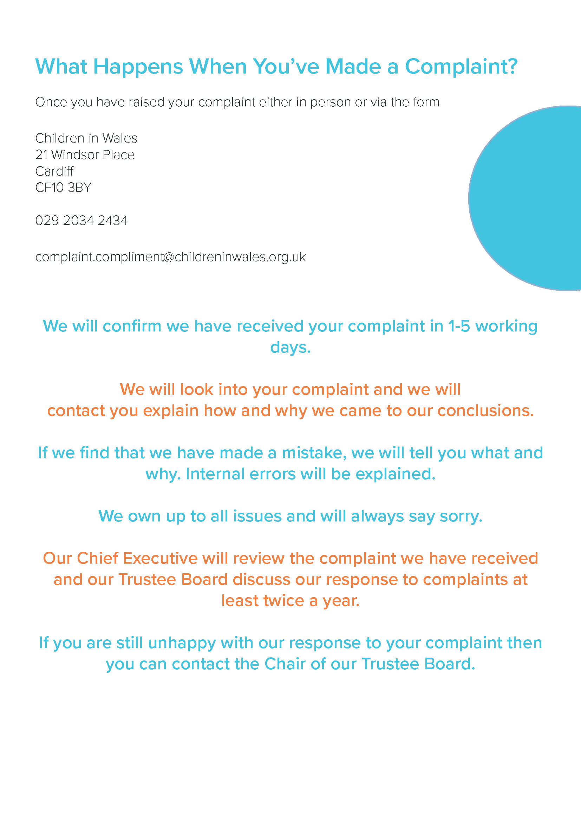

Complaints Form

Name: | Click or tap here to enter text.
Address and Postcode: | Click or tap here to enter text.
Email address: | Click or tap here to enter text.
Phone number: | Click or tap here to enter text.
How would you like us to contact you? | Click or tap here to enter text.
What are you unhappy with? Tell us what has happened:
Click or tap here to enter text.

What date did it happen?
Click or tap here to enter text.

What could be done to make you happy? Tell us what you’d like to happen:
Click or tap here to enter text.

If you have any documents that might support your complaint, please attach them or let us know.
Signature | Click or tap here to enter text.
Date | Click or tap here to enter text.

